**Project Design Phase-II**

**Technology Stack (Architecture & Stack)**

|  |  |
| --- | --- |
| Date | 03 October 2022 |
| Team ID | PNT2022TMID51091 |
| Project Name | Project – Plasma Donor Application |
| Maximum Marks | 4 Marks |

**Technical Architecture:**

The Deliverable shall include the architectural diagram as below and the information as per the table1 & table 2

Guidelines:

1. Include all the processes (As an application logic / Technology Block)
2. Provide infrastructural demarcation (Local / Cloud)
3. Indicate external interfaces (third party API’s etc.)
4. Indicate Data Storage components / services
5. Indicate interface to machine learning models (if applicable)

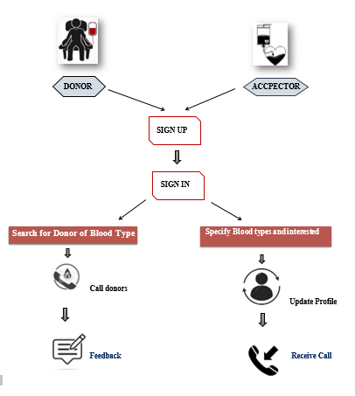

**Table-1 : Components & Technologies:**

|  |  |  |  |
| --- | --- | --- | --- |
| **S.No** | **Component** | **Description** | **Technology** |
|  | User Interface | The user register and login.  See the UI. | HTML, CSS, Python Flask |
|  | Data maintenance | Store , maintain ,retrieve the user’s details. | MYSQL |
|  | Chatbot | Clarify user queries. | BM Watson service |
|  | Confirmation Email | Sending the confirmation email to users they have registered successfully. | SendGrid |
|  | Cloud Database | Cloud database to store plasma information and View Plasma information. | IBM DB2 |
|  | File Storage | File storage requirements | IBM Block Storage |
|  | Infrastructure (Server / Cloud) | To deploy the application on Local System | Kubernetes |

**Table-2: Application Characteristics:**

| **S.No** | **Characteristics** | **Description** | **Technology** |
| --- | --- | --- | --- |
|  | Open-Source Frameworks | Python Flask frameworks is used. | Python Flask |
|  | Security Implementations | Mandatory Control(MAC) and kubernetes is used. | SHA-256, Encryptions, IAM Controls, OWASP etc. |
|  | Scalable Architecture | 3-Tier Architecture is used. | Web server-HTML,CSS Application Server- Python Flask Database Server-IBM DB2 |
|  | Availability | Using Load Balancer to distribute network traffic across Servers. | IBM Load Balancer |
|  | Performance | User Friendly UI. Request and Response is faster. | IBM Content Delivery Network |